Order It- Android Based Food Ordering System

A Project Report submitted in partial fulfillment of the requirements for the award of the degree

In

MASTER OF COMPUTER APPLICATIONS

By

K. JAYACHANDRA
15781F0021

UNDER THE GUIDANCE OF
Mr. A.M. RANGARAJ, MCA, M.Tech
Associate Professor
DEPARTMENT OF COMPUTER APPLICATIONS
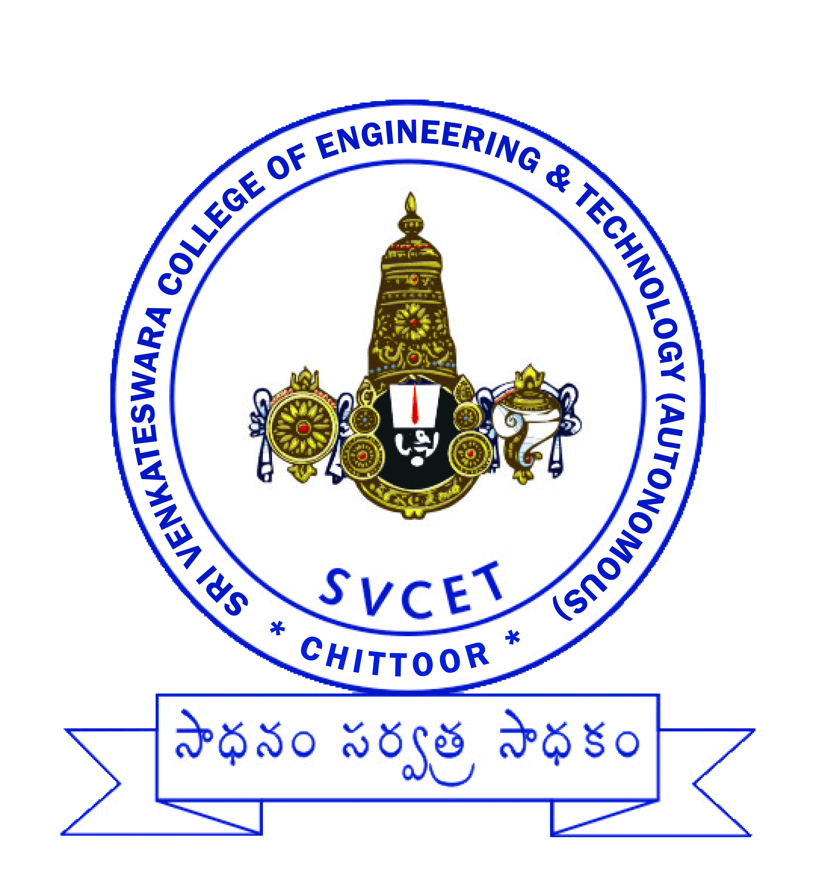

DEPARTMENT OF COMPUTER APPLICATIONS
SRI VENKATESWARA COLLEGE OF ENGINEERING & TECHNOLOGY
[AUTONOMOUS]
(Affiliated to JNTUA, Anantapuramu , Approved by AICTE, New Delhi)
(Accredited by NAAC, Bangalore.)
R.V.S.NAGAR, Chittoor (A.P)-517127

MAY 2018
SRI VENKATESWARA COLLEGE OF ENGINEERING & TECHNOLOGY
[AUTONOMOUS]
(Affiliated to JNTUA, Anantapuramu , Approved by AICTE, New Delhi)
(Accredited by NAAC, Bangalore.)
R.V.S.NAGAR, Chittoor(A.P)-517127

BONAFIDE CERTIFICATE

Certified that this project report titled “ORDER IT- ANDROID BASED FOOD ORDERING SYSTEM” is the bonafide work of Mr. K. JAYACHANDRA (15781F0021) who carried out the project work under our supervision, as part of his final semester project.

A.M. RANGARAJ,  MCA, M.Tech,  Associate Professor,  Dept of Computer Applications  SVCET, Chittoor. | Mr. N.SENDHIL KUMAR,  MCA, M.Tech, (Ph.D),  Associate Professor,  HOD, Computer Applications,  SVCET, Chittoor. | Dr. P.BHASKAR,  M.Tech(IISc).,Ph.D(UK)  PRINCIPAL,  SVCET, Chittoor.

SRI VENKATESWARA COLLEGE OF ENGINEERING & TECHNOLOGY
[AUTONOMOUS]
(Affiliated to JNTUA, Anantapuramu , Approved by AICTE, New Delhi)
(Accredited by NAAC, Bangalore.)
R.V.S.NAGAR, Chittoor(A.P)-517127

Certificate of evaluation

College Name : sRI VENKATESWARA COLLEGE OF eNG. & TECH

BRANCH : MASTER OF COMPUTER APPLICATIONS

NAME OF THE STUDENT : K. JAYACHANDRA

PROJECT TITLE : ORDER IT- ANDROID BASED FOOD ORDERING
SYSTEM

The project work report submitted in partial fulfillment for the award of MCA degree in JNTUA, ANANTAPURAMU is evaluated and confirmed to be report of the work done by the above student.

Submission for the project viva voice held on ______________

INTERNAL EXAMINER EXTERNAL EXAMINER

SRI VENKATESWARA COLLEGE OF ENGINEERING & TECHNOLOGY
[AUTONOMOUS]
(Affiliated to JNTUA, Anantapuramu , Approved by AICTE, New Delhi)
(Accredited by NAAC, Bangalore.)
R.V.S.NAGAR, Chittoor(A.P)-517127

DECLARATION

I here by declare that the project work entitled “Order It- Android Based Food Ordering System” is a genuine work carried out by me under the guidance of A.M. Rangaraj, MCA, M.Tech, Associate Professor, of the Department of Computer Applications, in partial fulfillment for the award of the degree in “MASTER OF COMPUTER APPLICATIONS” of JNTUA, Anantapuramu.

K.JAYACHANDRA
15781F0021

